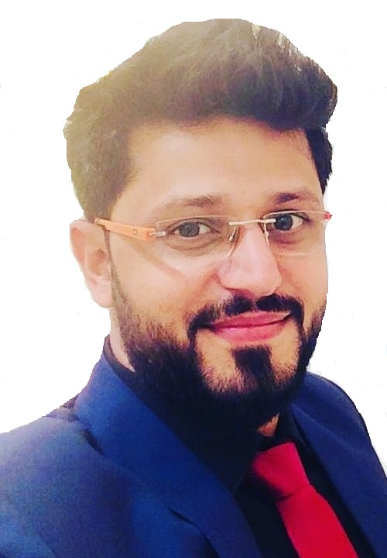
SAURABH KUMAR
(B.Tech. Electrical)
Mobile : +91 9929779719, E-mail : acmesaurabh@gmail.com

Seeking assignments in Electrical Engineering with an organization of repute

BRIEF OVERVIEW

- A competent individual with 6+ years of experience having a degree of B.Tech. (Electrical) from Rajasthan Technical University.
- Acquired knowledge and understanding of different subjects such as Electrical Machine, Power electronics etc.
- Successfully completed a project on MAGLEV (Magnetic train) at Jaipur Engineering College.
- Excellent team player with strong analytical and leadership skills.
- Conversant with Internet Application and its uses.
- Ability in learning new concepts quickly and communicating ideas effectively.

EDUCATION

- B.Tech. (Electrical) from Jaipur Engineering College, Jaipur in 2012.
- 12th from B.S.E.B, Patna in 2008.
- 10th from B.S.E.B, Patna in 2006.

WORK EXPERIENCE

From: March 2016 to till Date
Position: Sr. Electrical Engineer
Organization: M/s Siemens Limited through M/s Kanthwal Services

Project Name: Metro Express Link from Gandhinagar to Ahmedabad (MEGA)
Role in Project: Electrical Design Engineer
Responsibility: Design of 4 Nos.132/33kV Receiving Sub Stations at Ahmedabad
- To perform Equipment Sizing Calculation.
- Earthing Calculation as per relevant Standards.
- DSLP Calculation as per relevant Standards.
- Battery Sizing Calculation as per relevant Standards.
- Preparation of Equipment & Cable Trench Layout, Power & LV Cable schedule.
- Illumination Calculation of Control room building.
- Preparation of Testing Schedule Format to Conduct Inspection/Factory Acceptance Test for equipment’s.
- All the technical discussion & Interface with PSA.
- To closely co-ordinate with team members for finalization of engineering drawings/documents.
- Monthly Project Review Meetings along with the Customer for Tracking the Project Status.

Project Name: Noida-Greater Noida Metro (NE-01)
Role in Project: Electrical Design Engineer
Responsibility: Design of 21 Nos.33/.415 kV Auxiliary Sub Stations.
- To study & review offers of Cables, Station auxiliary & Traction transformers, ACDB/DCDB, Battery & Battery Charger etc as per contract requirement & design standards.
- Involved in preparation of design documents & Calculation (Equipment Layout, Earthing Design, Cable Trench Layout, Cable schedule, lightning calculation & layout finalization etc.
- Preparation of Testing Schedule Format to Conduct Inspection/Factory Acceptance Test for equipment’s.
- All the technical discussion & Interface between Station Contractor along with General Consultant.
- To closely co-ordinate interdepartmental with team members for finalization of engineering drawings/documents.
- Monthly Project Review Meetings along with the Customer for Tracking the Project Status.
- Design and verification of Cable Contentment for LT System of Elevated Stations.
- To review package engineering status on a day to day basis to avoid delay in document submissions & approvals.
- To closely co-ordinate with team members for finalization of engineering drawings/documents.

Project Name: Delhi Metro Rail Corporation (DMRC)
Role in Project: Electrical Design Engineer
Responsibility: Design of 220/33/25kV Receiving Sub Stations at Kashmiri Gate RSS
- Optimization of Space in Equipment Layout.
- Earthing Calculation as per relevant Standards.
- DSLP Calculation as per relevant Standards.
- Battery Sizing Calculation as per relevant Standards.
- Preparation of Equipment & Cable Trench Layout, Power & LV Cable schedule.
- Illumination Calculation of Control room building.
- Preparation of Testing Schedule Format to Conduct Inspection/Factory Acceptance Test for equipment’s.
- All the technical discussion & Interface with PSA.
- To closely co-ordinate with team members for finalization of engineering drawings/documents.
- Monthly Project Review Meetings along with the Customer for Tracking the Project Status.

From: December 2014 to March 2016
Position: Project Engineer
Organization: FELICITY ESTATES PVT. LTD

Project Name: Site Solitaire
Role in Project: Project Engineer
Responsibility: Installation & testing Commissioning of HT/LT System.
- Develops Project objectives by reviewing Project proposal and plans.
- Determine Project responsibilities by identifying Project phases and elements.
- Determine Project specification by studying Project drawings & product designs.
- Determine Project schedule by studying Project plans and specifications.
- Maintain Project schedule by monitoring Project progress; coordinating activities resolving problems.
- Control Project cost by approving expenditure.
- Maintains safe & clean working environment by rules and regulation.
- Maintain Project data base by writing computer programs; entering and backing up data.
- Contributes to team effort by accomplishing related results as needed.

From: June 2014 to December 2014
Position: MEP Coordinator
Organization: EMC (Electro-Mech Consultant)

Project Name: Mahima Group/ Aventura Group/ Skyline Services
Role in Project: Coordinator
Responsibility: Co-ordination with the Clients.
- Planning
- Budgeting
- Preparing technical documents
- Hiring personnel
- Coordinating project members
- Ensuring safety
- Handling invoices
- Supervising subcontractors

From: May 2013 to May 2014
Position: MEP Engineer
Organization: ACCIL Corporation Ltd, Gurgaon

Project Name: Holiday Inn Jaipur City Centre (5Star Hotel Property).
Role in Project: MEP Site Engineer
Responsibility: Installation & testing Commissioning of MEP System.
- STP commissioning (Including Civil works, mechanical and electrical parameters) has been done in my guidance.
- POOL DECK (The all works in swimming pool are going on in my provision such as civil as well as the electrical and mechanical terms) work is on progress but the things which are related to the pool deck is guiding by me and the report submit to the project head.
- SOLAR SYSTEM installation and commissioning are in my guidance.
- CIVIL works billing is also in my scope.
- The all services such as LT, HT panel, STP, WTP, Chiller Plant, Firefighting and Boiler Plant etc. are handling in my presence, but the main role who handled the all services is Services head.
- Installation of CCTV cameras.

From: July 2012 to May 2013
Position: Electrical Site Engineer
Organization: Pink City Build Home Pvt. Ltd.

Project Name: Radission Blu Jaipur Airport Plaza (5Star Hotel Property).
Role in Project: Electrical Site Engineer
Responsibility: Installation & testing Commissioning of MEP System.
- Site making decision and project execution analysis
- Close coordination and monitoring of the projects.
- Coordination with Various Contractors.
- Coordination with various Consultants and Architects
- Project execution and Reporting to management
- Bar Chart preparation and Scheduling.
- Time keeping schedule
- Quality and cost controlling
- Bill certification
- Handing over to Client (Management Client)

IT SKILLS

Languages C, C++ Basics
Operating Systems Windows 7
Tools MS Office, MS Excel, CADD, Requirement management tools (DOORS)

ACADEMIC PROJECTS

Title MAGLEV (Magnetic train)
Organization Jaipur Engineering College
Description In the project we had studied the principle of the magnetic train which is having the potential of
Becoming the next generation of transport.

SUMMER TRAINING

Organization CHINHAT 220 KV G.S.S in Lucknow under U.P.P.C.L
(Uttar Pradesh Power Corporation Ltd.) in 2011.
Description Overall working of a GRID SUB-STATION.

EXTRACURRICULAR ACTIVITIES

Participated in:
- Served as Event Manager in JAM (An Elocution Competition) in College Annual Technical Fest, 2011.
- Served as Head Coordinator in Dondemode in College Annual Technical, 2011.
- Served as Event Coordinator in JAM (An Elocution Competition) in College Annual Fest, 2010.
- Co-ordinate the XIIIth ISTE National Convention in College in October 2010.
- Participate in college sports event “ALAKRITY” as senior members of volunteer.

ACHIEVEMENTS

- Secured a MERIT RANK in a national level I.T Aptitude test organized by the NIIT.
- Member of NEN (National Entrepreneurship Network) and appointed as E-leader.
- Executive member of ISTE (Indian Society for Technical Education).
- Participate in “Paper Presentation Competition” under Electrical Week 2010.

KEY SKILLS

- Team oriented person with strong determination.
- Good presentation, communication and inter-personal skills.
- Have steep learning curves.
- High degree of persistence.
- Posses’ leadership skills.
- Keen interest in internet surfing, reading novels and working.

PERSONAL DOSIER
Date of Birth | : | 14 January 1992
Gender | : | Male
Father's Name | : | Mr. Kamlesh Singh
Mother's Name | : | Mrs. Meena Devi
Nationality  Maritial Status | :  : | Indian  Married
Languages Known | : | English, Hindi
Address | : | C/o Mr. Saurabh Kumar  Flat No-114 Patrakar Vihar apartment  Nyay khand-I, Indirapuram, Ghaziabad-201010  Contact No-9929779719

Place: New Delhi

Date: 28th August ‘18 (Saurabh Kumar)

